Task Two Massage Therapist 3 min.

- Professional skills
- Personal characteristics
- Appearance
- Duties

3A | 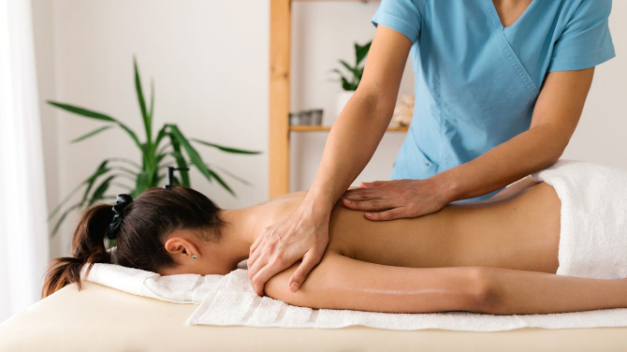 | 3B | 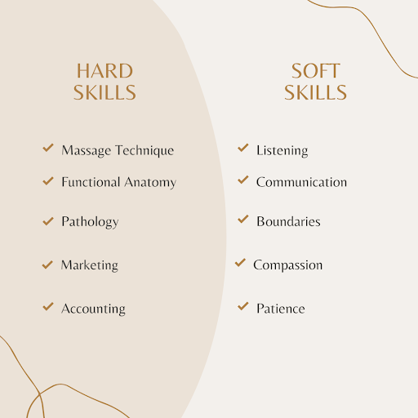
3C | 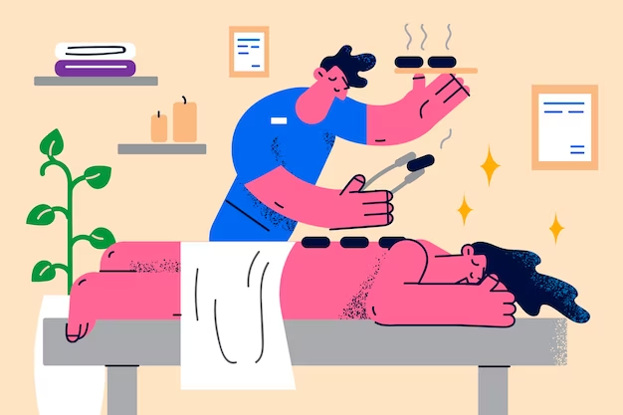 | 3D | 

Thank you. This is the end of the examination.

